**OBJECTIVE:**

To evaluate the financial performance and position of the organization by examining historical and current financial data, in order to provide actionable insights that support strategic decision-making, risk management, and future financial planning.

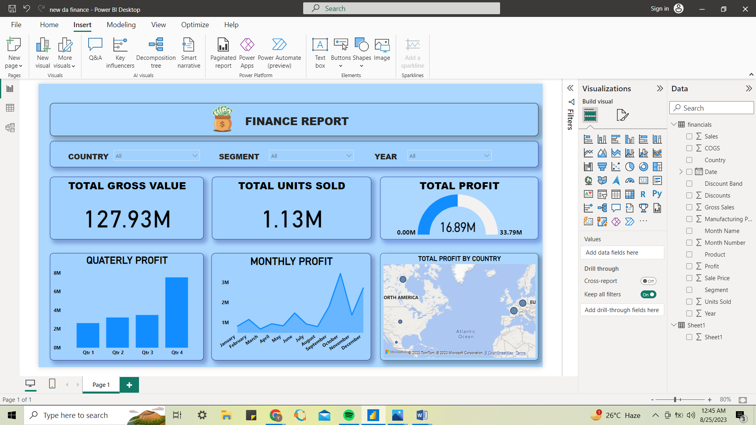

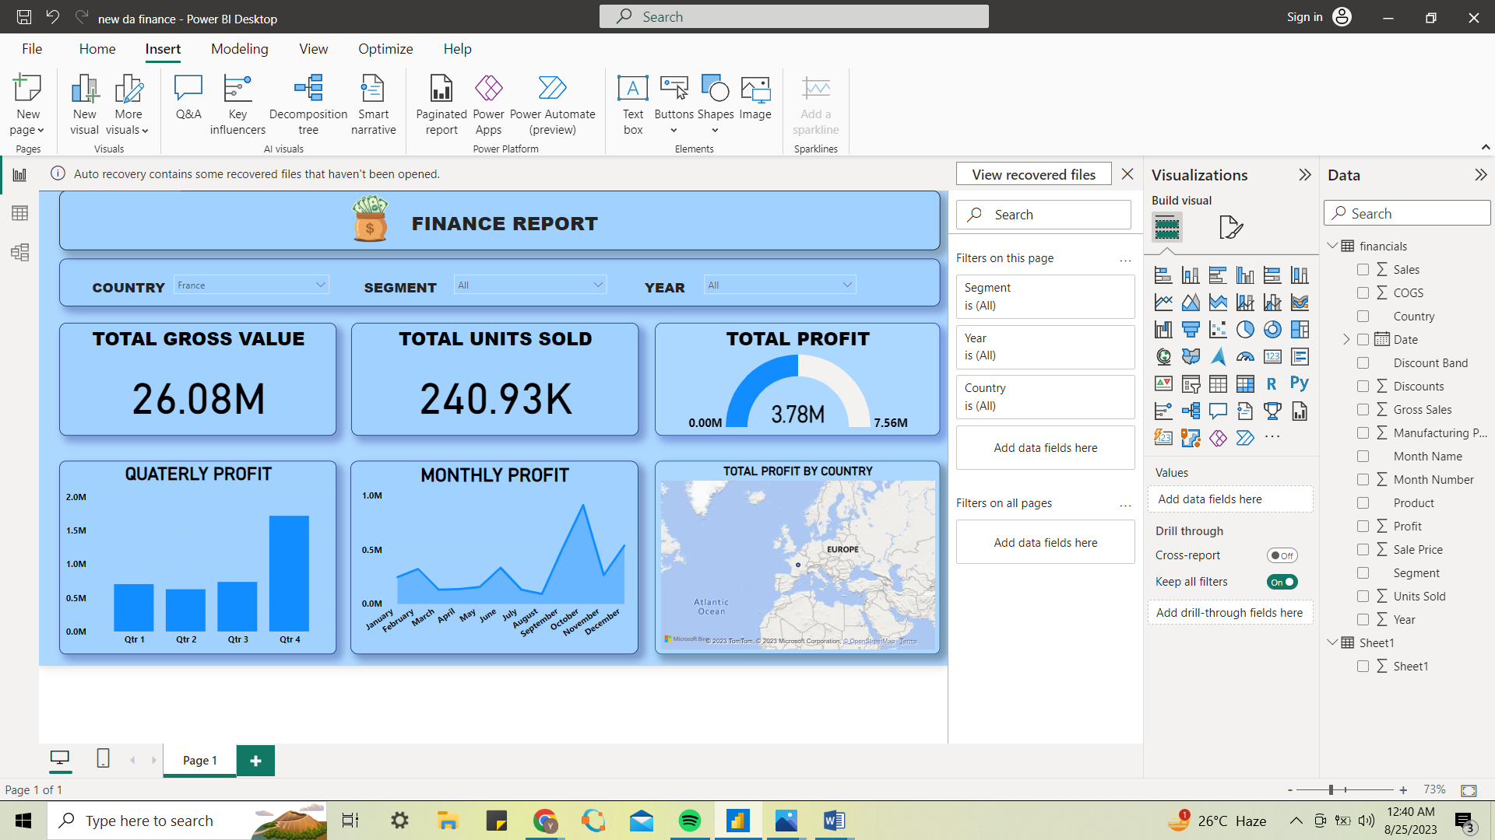

**PROJECT INSIGHTS:**

**Performance Metrics:**

Total Units Sold: With 1.13 million units being sold, this shows strong demand for the product or service. It would be useful to compare this with past years or months to get an understanding of growth or decline.

Gross Value: A gross value of 127.93M is significant. It could be insightful to know the cost of production or service provision to understand net values.

Profit Margin: The profit of 16.89M on a gross value of 127.93Mequates to a profit margin of approximately 13.2%. This means that for every dollar earned, roughly 13 cents is profit.

**Seasonal Trends:**

The months of October and December are particularly strong in terms of profit. This could be due to several reasons:

Seasonal demand (e.g., holiday shopping if it's a consumer product).

Year-end purchases for businesses.

Promotional activities or sales in those months.

Understanding the cause for this spike can help in better inventory management and marketing strategies for future.

**Geographical Insights:**

**France** being the top profit generator is noteworthy. With a profit of 3.78M, it contributes to approximately 22.4% of the total profit (3.78M of 16.89M). This indicates the strong market potential in France. Investigating further, it would be interesting to: Examine the marketing and distribution strategies in France.

Understandif there's a cultural or economic reason for the high demand. Compare the performance metrics of France to other countries to gauge any regional differences.

**Segment Analysis:**

The government segment being the most profitable segment implies a robust and stable demand, as government contracts or purchases tend to be large and recurring. It's crucial to:

Ensure good relations and fulfillment of contracts to retain this segment.

Look for opportunities to expand within this segment, perhaps in other departments or services.

Analyze the reason behind its profitability. Is it due to high volume or high margins?

**Recommendations for Action:**

Seasonal Demand: Consider aligning marketing and sales campaigns more towards October and December to further capitalize on the peak months.

Expand in France: If possible, allocate more resources or increase marketing efforts in France given its strong profit contribution.

Government Segment: Focus on building relationships and expanding within the government segment since it's highly profitable. Also, ensure timely and quality delivery to retain this crucial segment.

Analyze Costs: Given that profit is provided, it might be worthwhile to look into costs and see if there are any optimization opportunities, especially in segments or regions that aren't as profitable.